EXPERIMENT 2.1: DATA SPLITTING
AIM:
To split a dataset into training and testing sets using the train_test_split() function.
ALGORITHM:
- Import Pandas and train_test_split.
- Load the dataset from data.csv.
- Select Hours_Studied, Attendance, and Assignments as input features.
- Select Result as the target variable.
- Split the dataset into 80% training data and 20% testing data.
- Set random_state=42 to ensure reproducibility.
- Display the training data and testing data.
- Display the number of training and testing samples.
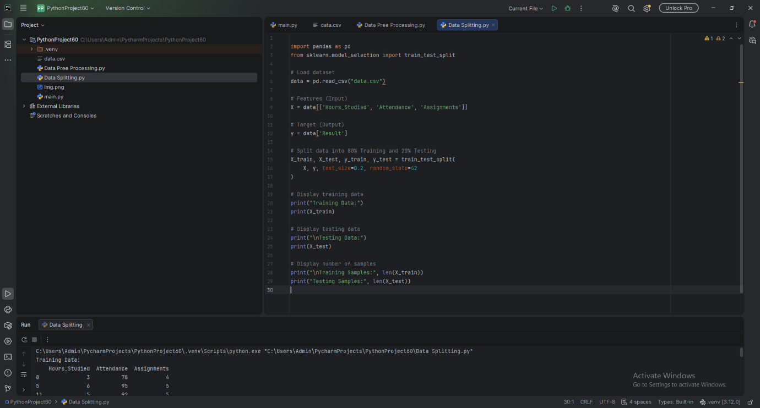
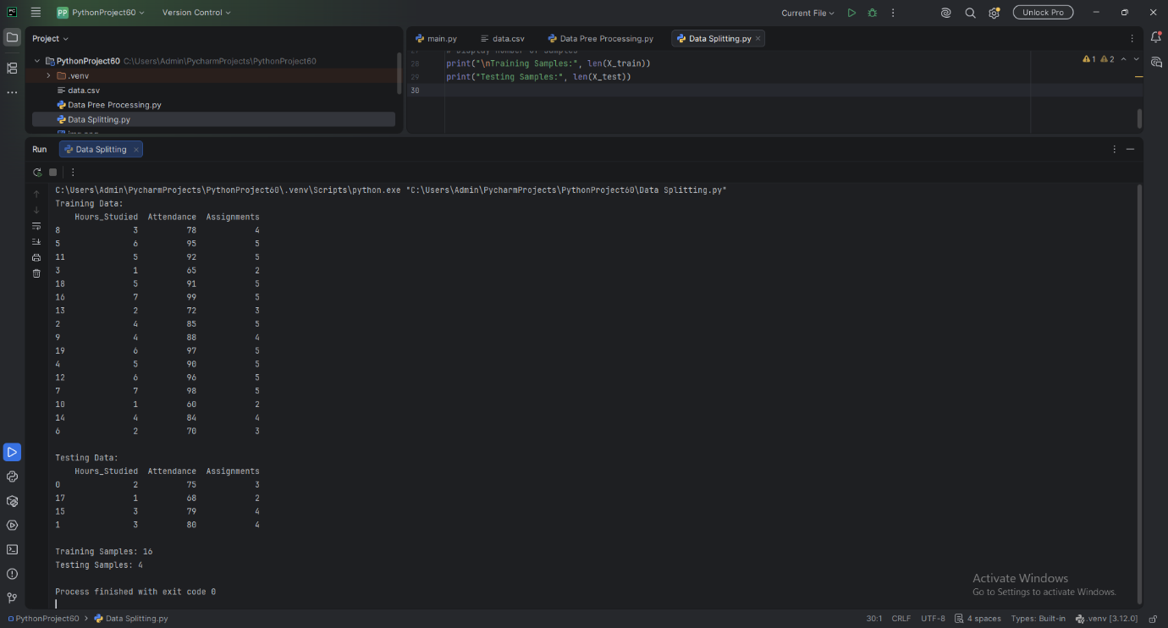

RESULT:
The dataset was successfully divided into training and testing sets in an 80:20 ratio.

